
Introduction to
Geographic Information Systems
Basic Training Guide – QGIS

Training course on Geo-Information for
Disaster Risk Management

By :
W.G.Gnanasukirthan.
Land Surveyor (B.Sc(SUSL), AMSISL)
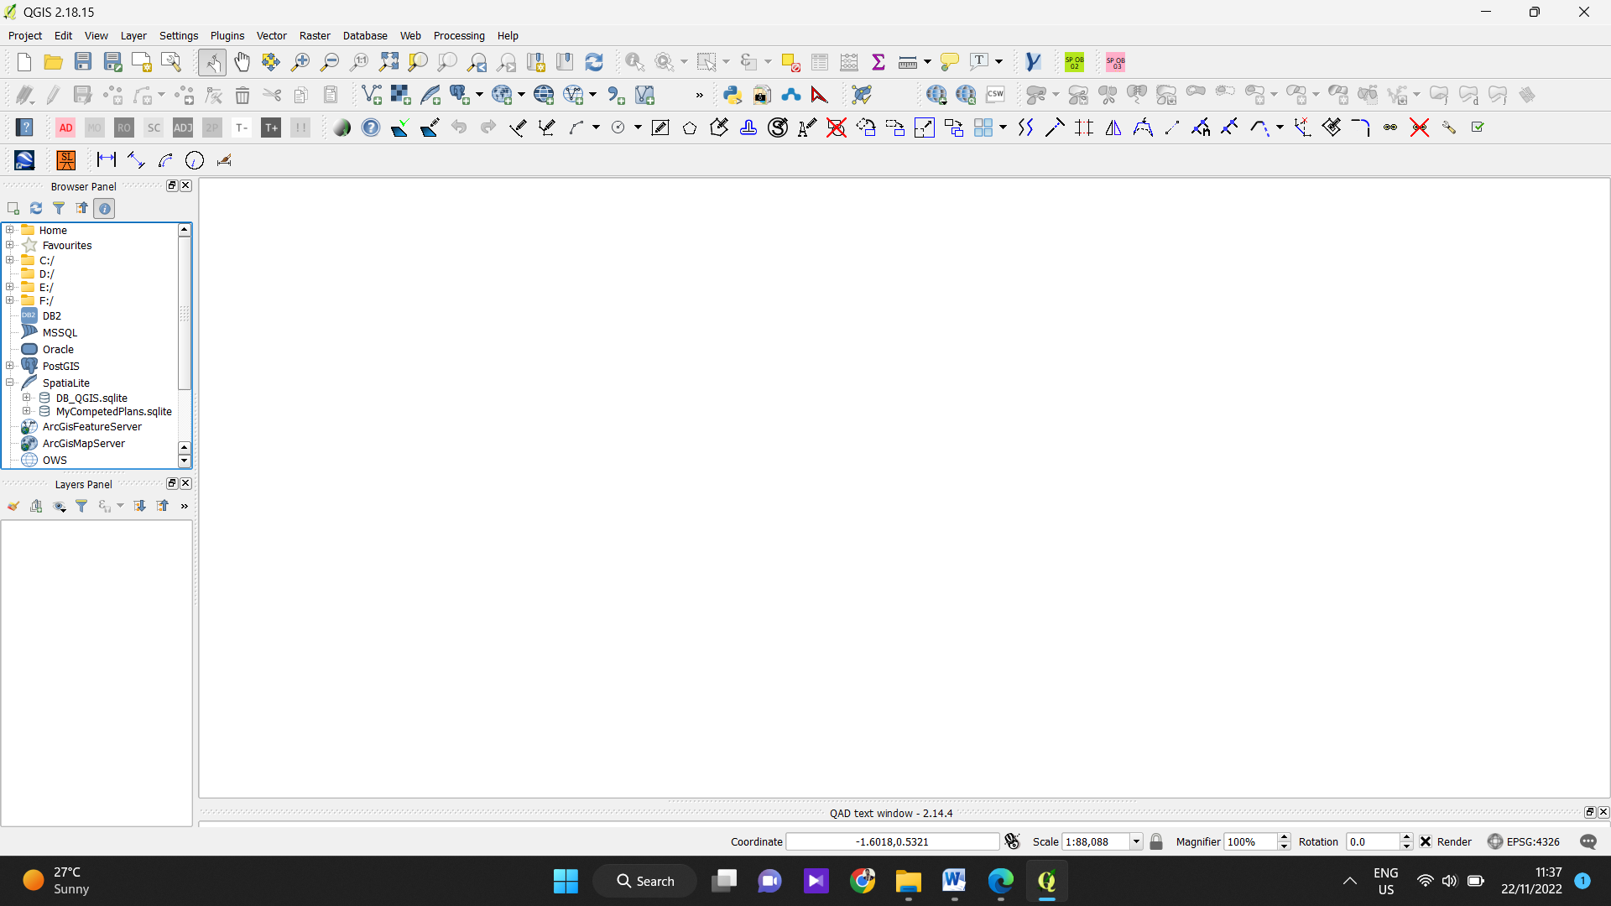
- Introduction to QGIS
4
1

1
1

2
1

3
1

5
1

6
1

1 | Menu Bar
2 | Browser Panel
3 | Layers Panel
4 | Tools Panels
5 | Map View/canvas
6 | Status Bar
Your window decorations (title bar, etc.) may appear different depending on your operating system and window manager.

Save the Project.

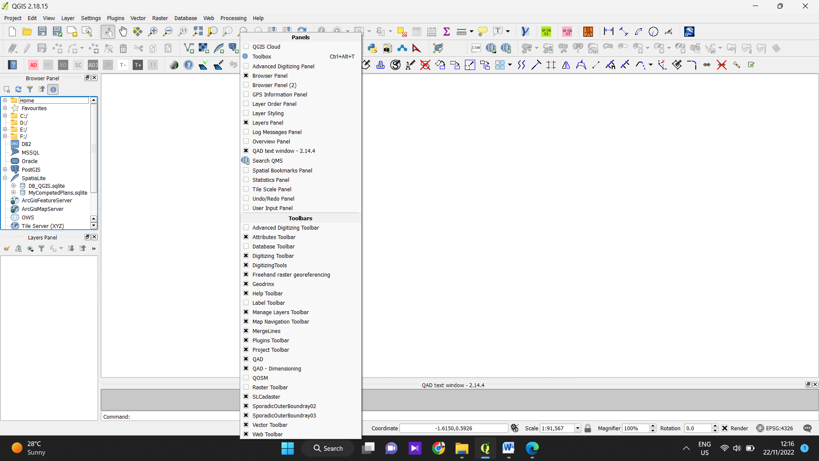
1.1 Right Click on Tools Panels & Check the below marked Panels & Toolbars in Active

- Add Vector Layer
Manage Layers tool bar > Add vector Layer
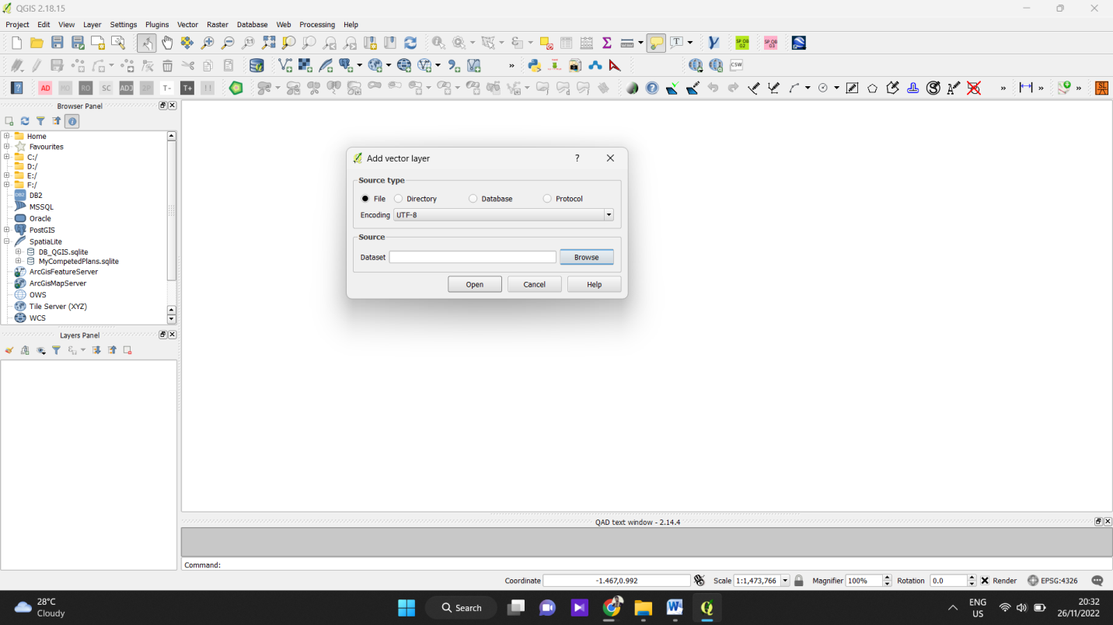
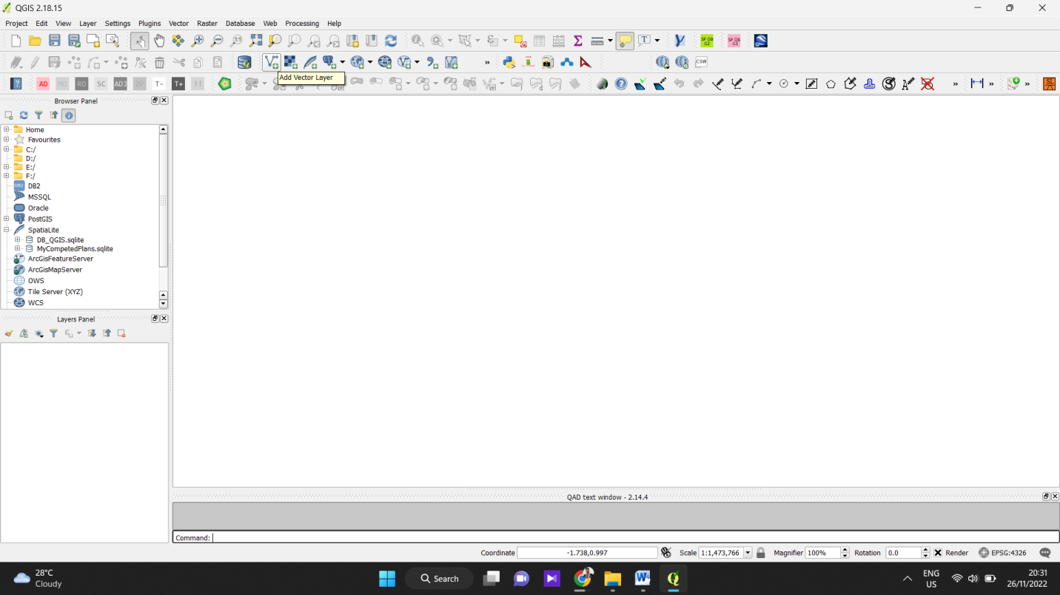
& Browse your Vector Data (MANNAR_TOWN.shp)

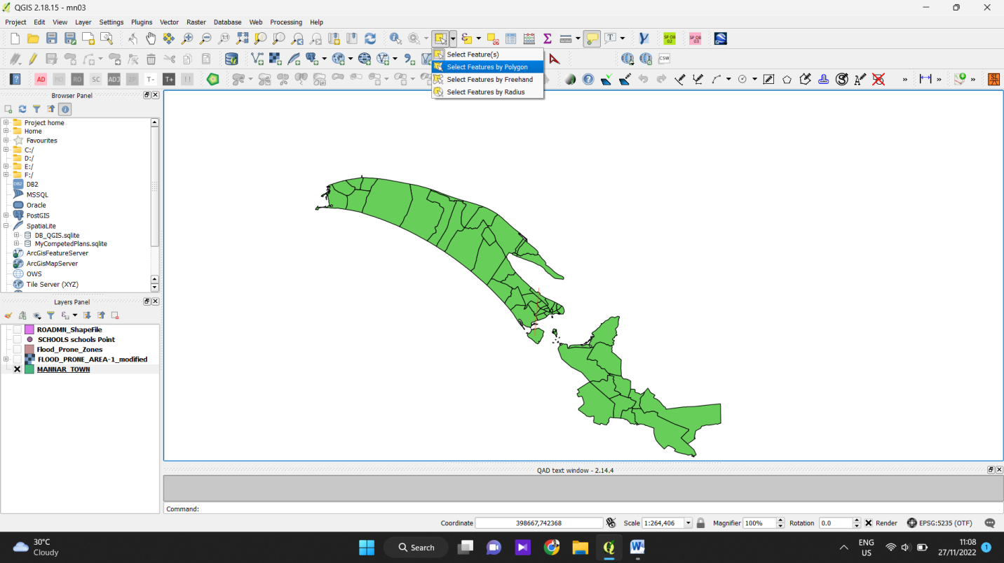
  - Select the study area.
Click on Select Feature polygon & Draw the AOI

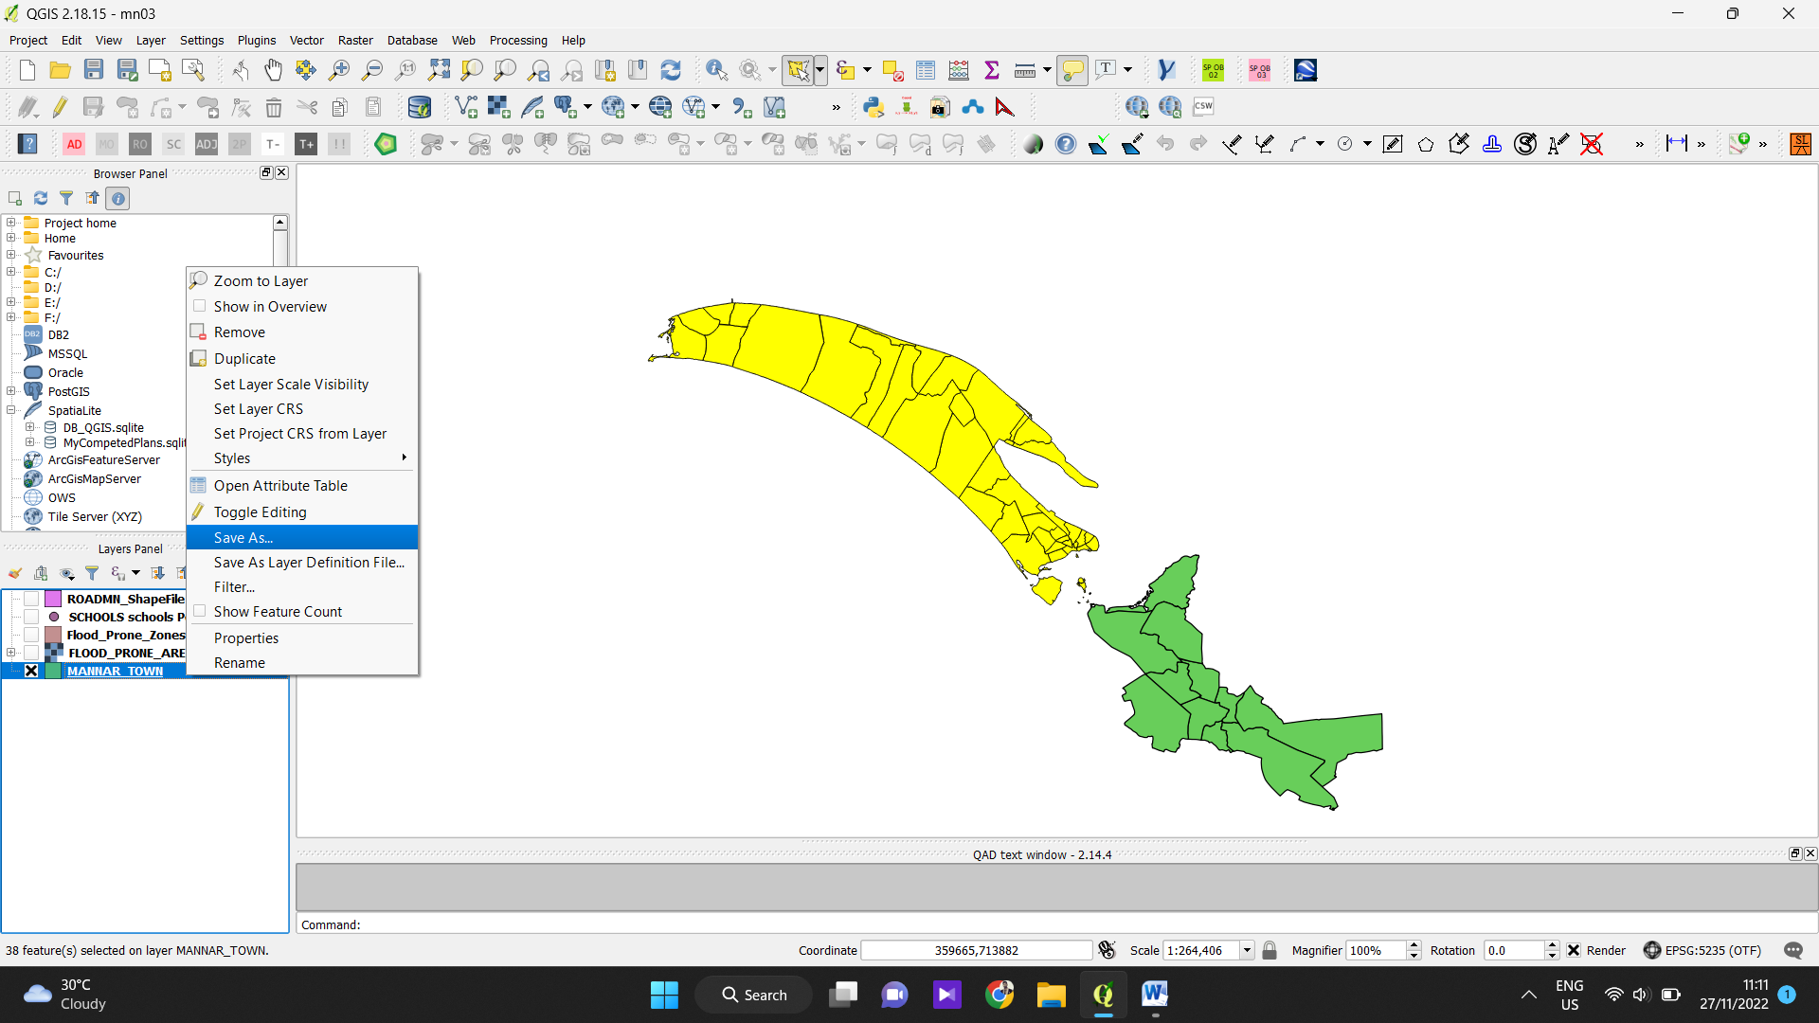
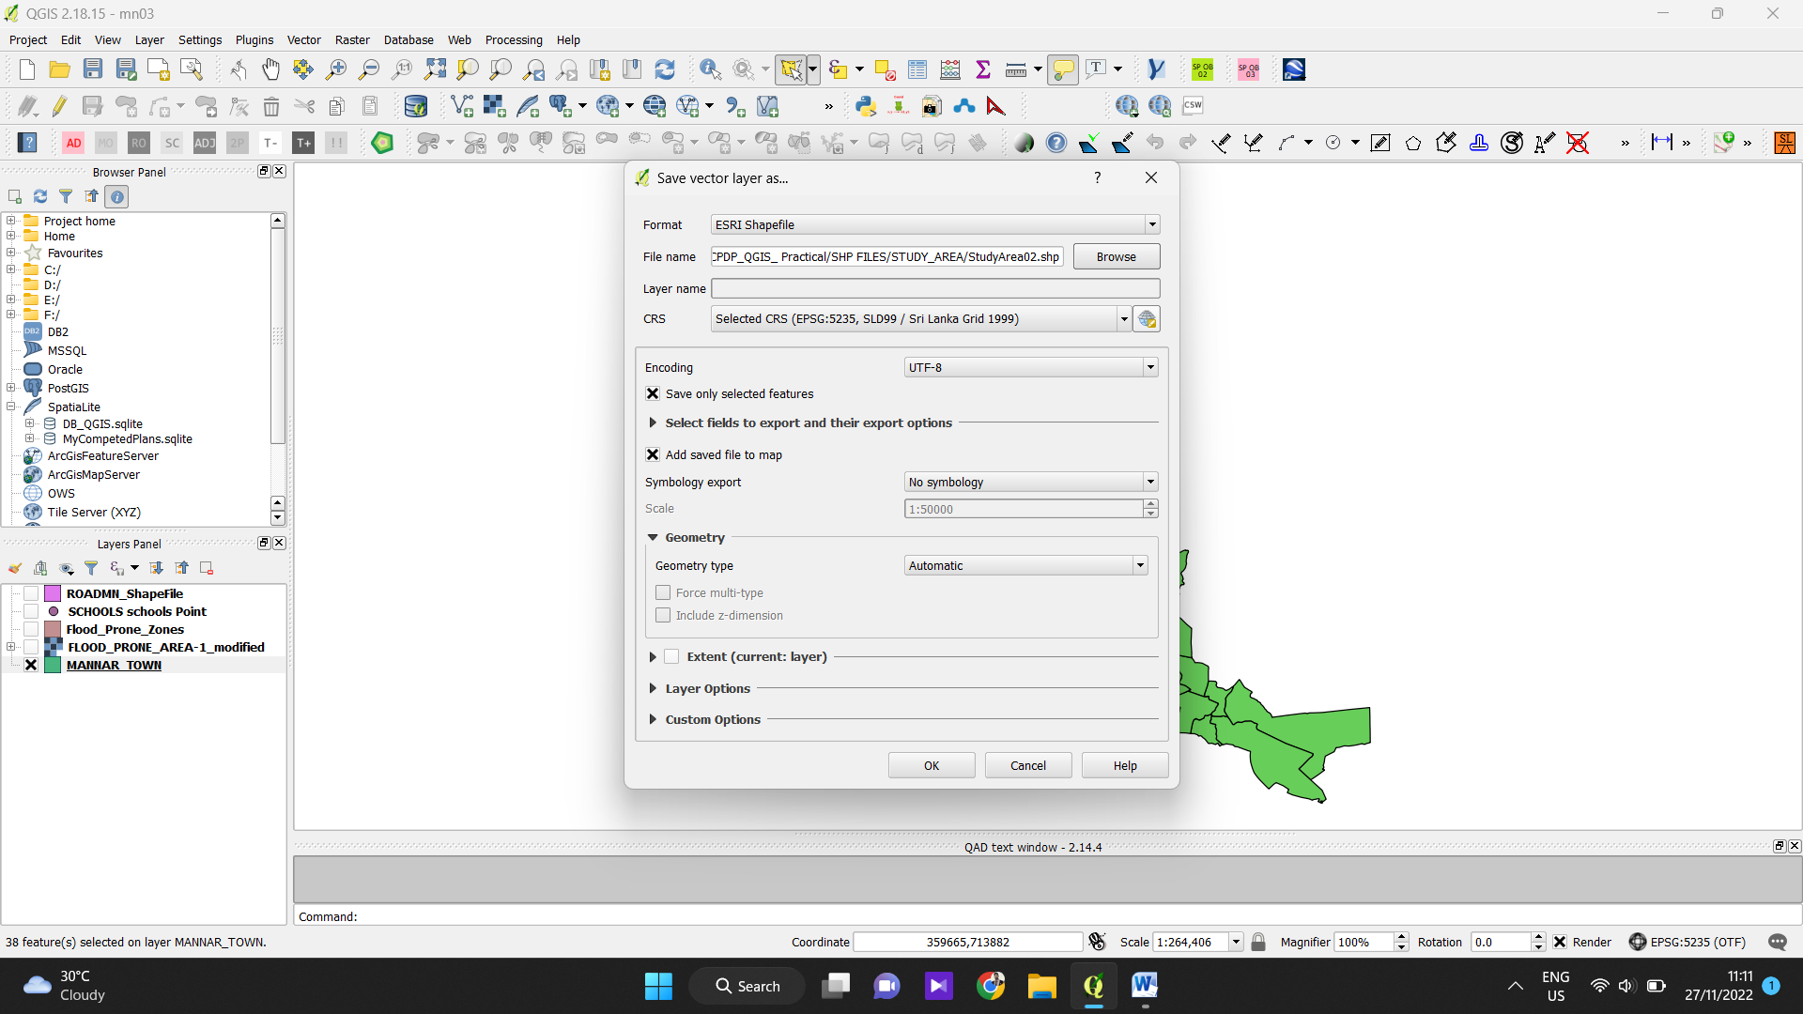

Save the Selected Features to a different ShapeFile.
Open Attribute Table.

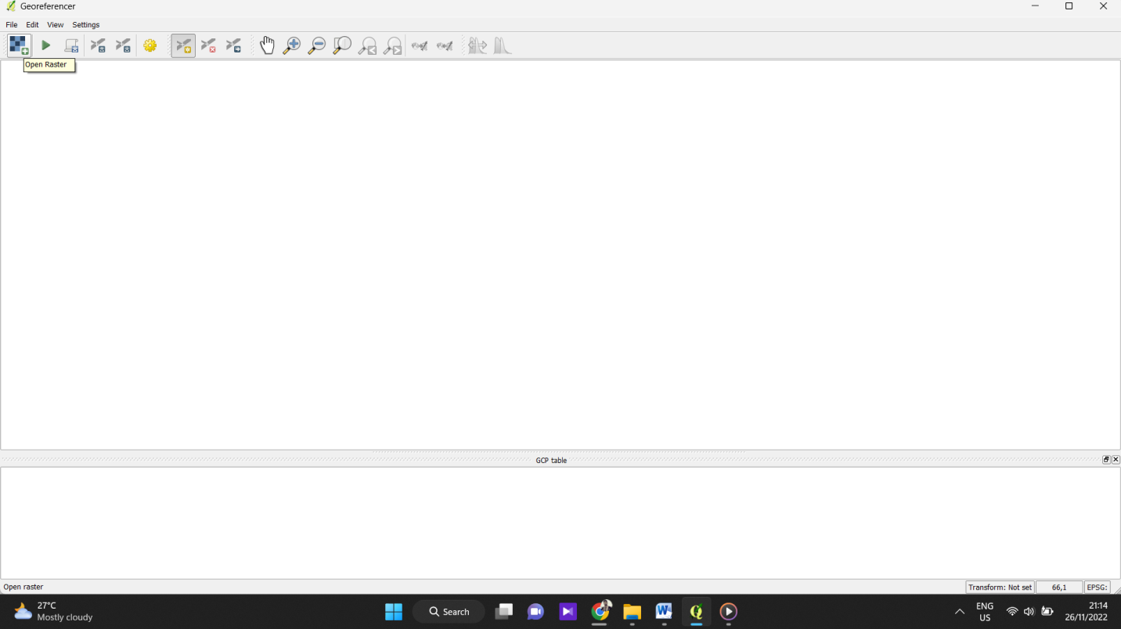
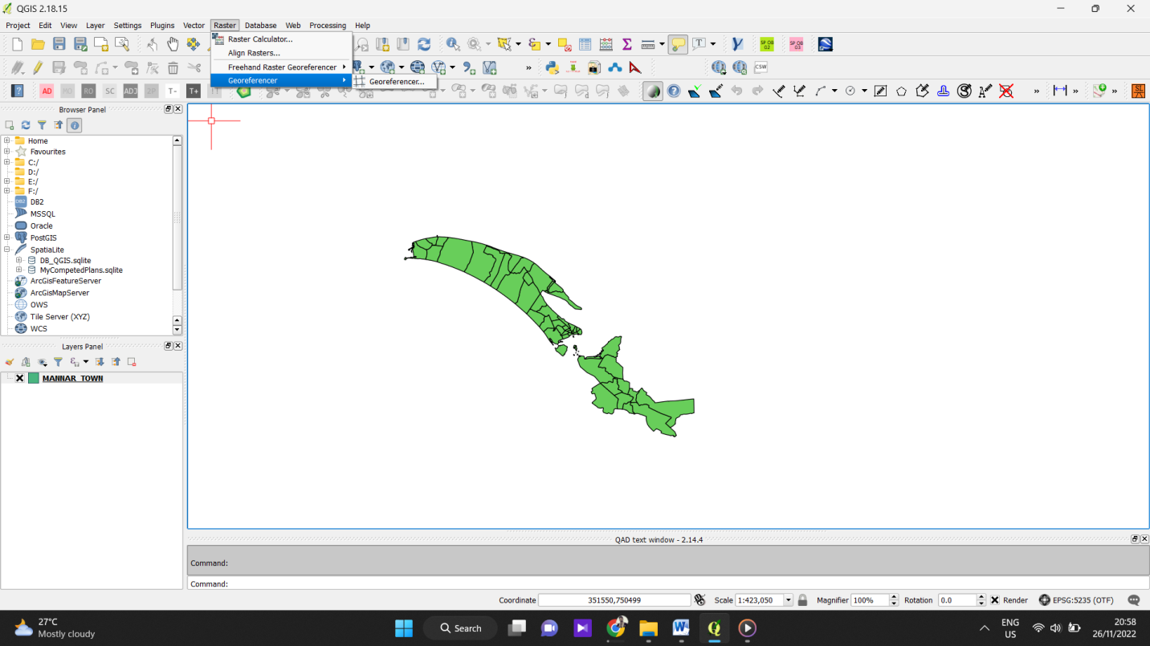
- Add Raster Data & Georeferencing.
Goto Raster > Georeferencer > Georeferencer.

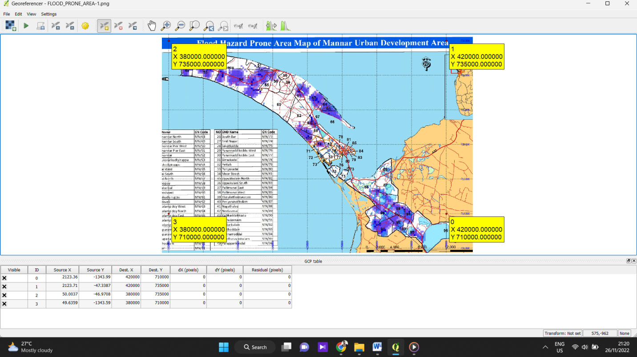
  - Open the Raster in Georeferencer Window.
(FLOOD_PRONE_AREA-1)

Georeference the Image with GCP Points.

  - Save the Georeferenced Imege
Goto Transformation Setting > Select Coordinate System& Save File.
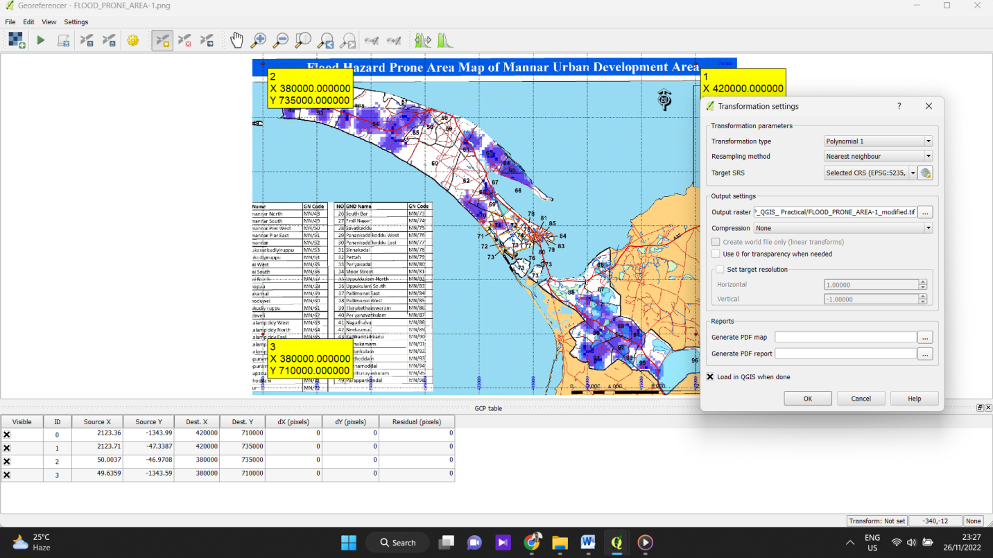

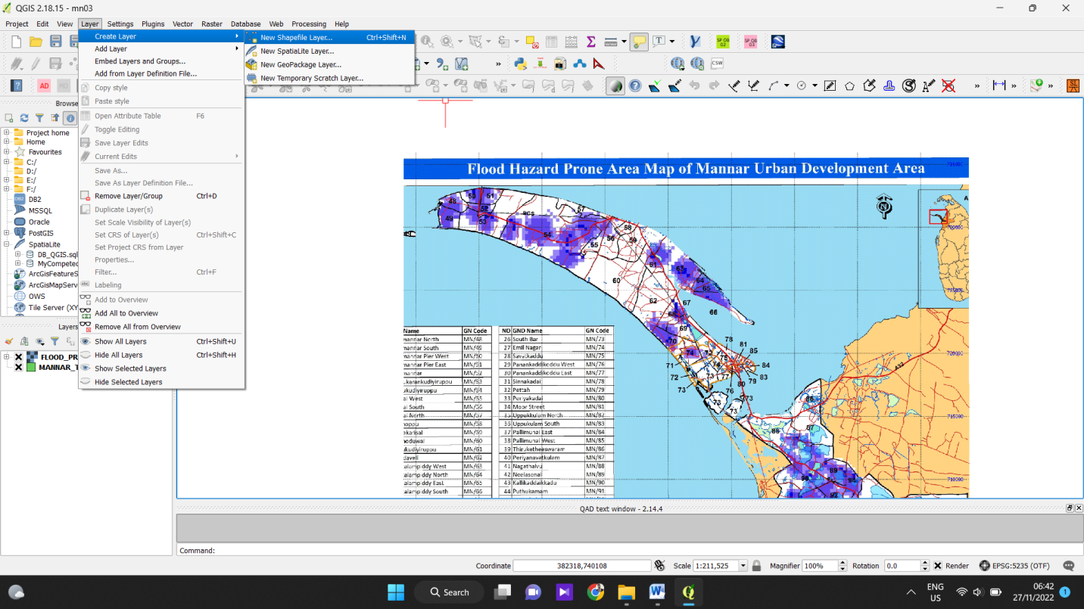
- Create the Layer Files (Prone Zones).
Layer > Create Layer > New Shape File
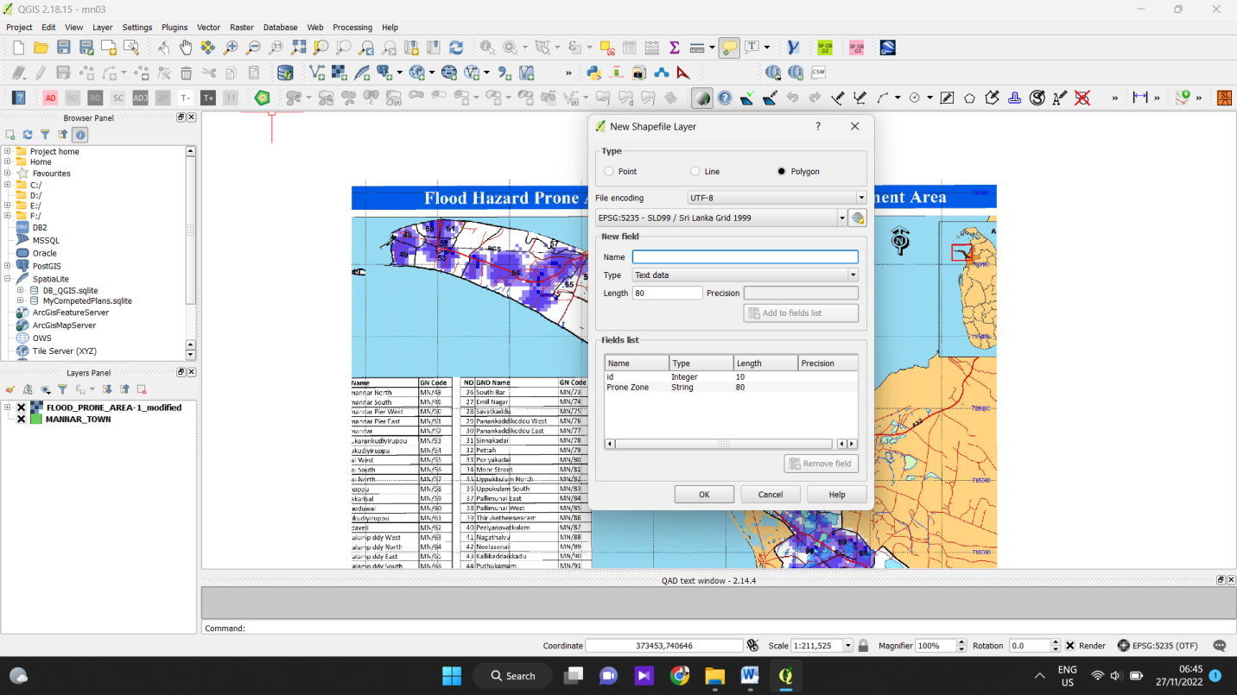
Select Polygon, Coordinate System & Add fields.
Save the Layer to your folder as Flood_Affected_Zones.shp

  - Start the Digitizing Process.
Select Flood_Affected_Zones shp in Layer Panel & on the Toggle Editing > add feature > then start the digitizing Process.
Save the Edits & off Toggle Editing.

  - Add Road ShapeFiles of Mannar (Roads_Mannar)

  - Add KML to Map & Save as Shapefiles.

- Disaster Relief Centres.

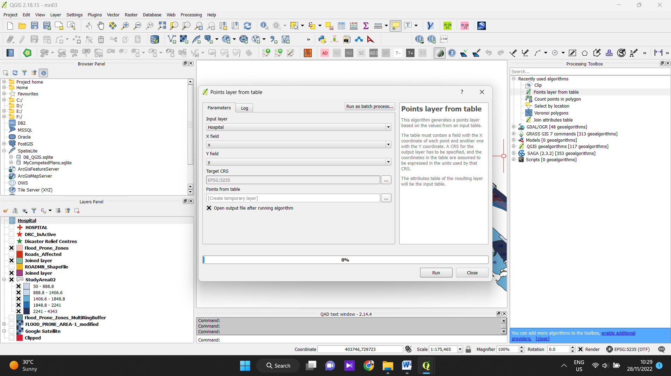
- Hospital locations from Excel Sheet.

Analysis
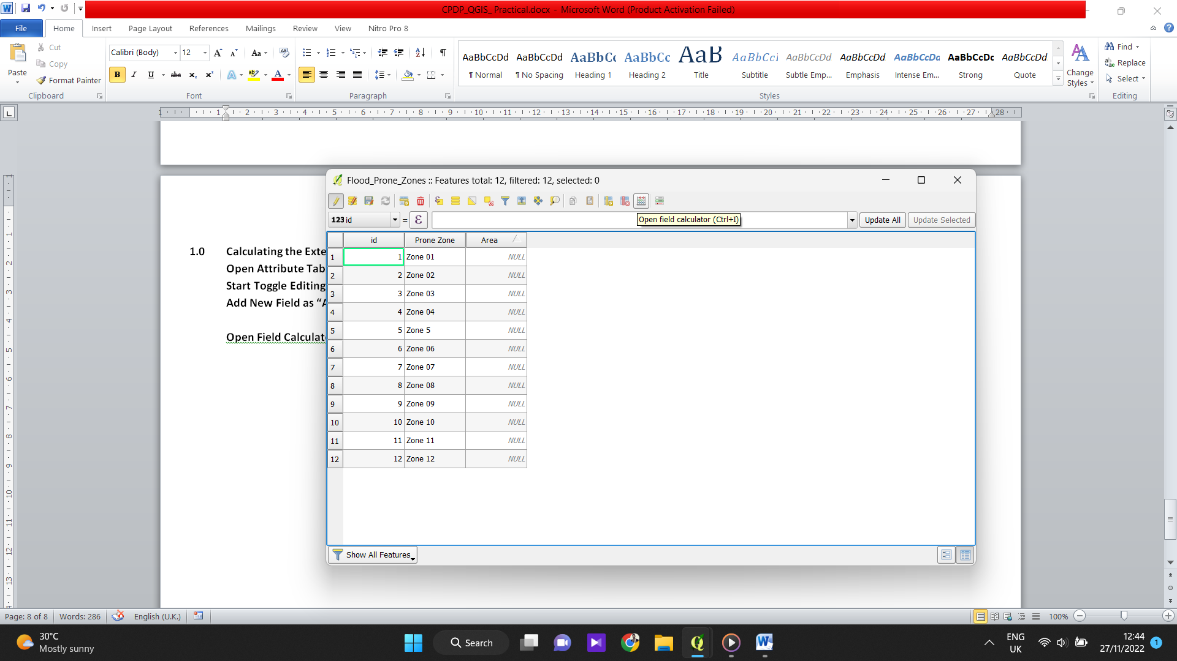
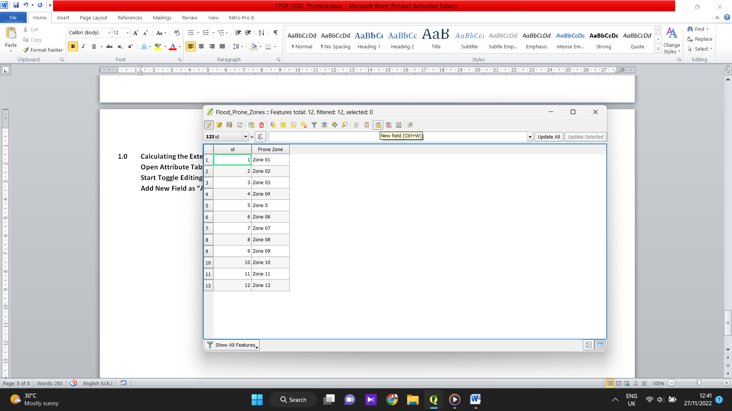
- Calculating the Extents of Flood Prone Areas.
Open Attribute Table of the Layer.
Start Toggle Editing.
Add New Field as “Area”.

Open Field Calculator.

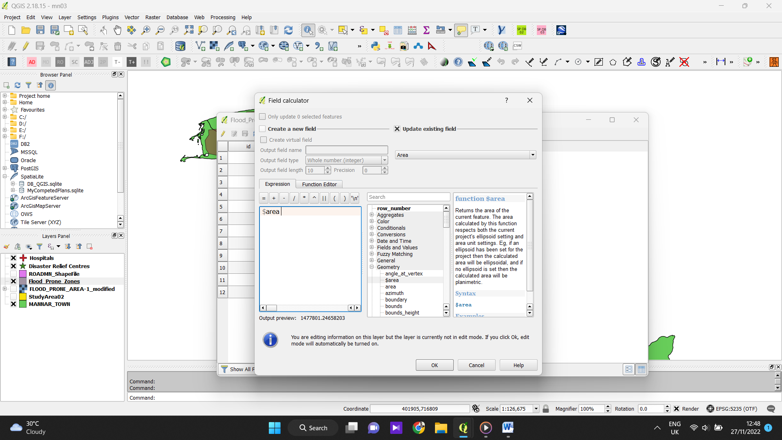
Calculate the Area.

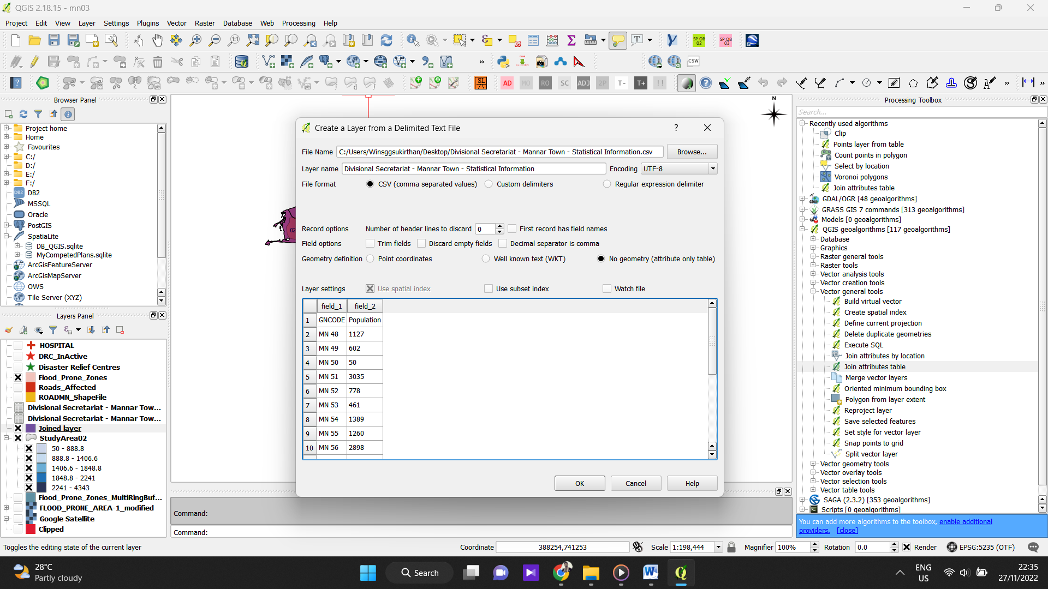
Population Data
Add the Population Data CSV to map.

Select ‘Join Attribute Tables’ from Processing tool box & join both tables
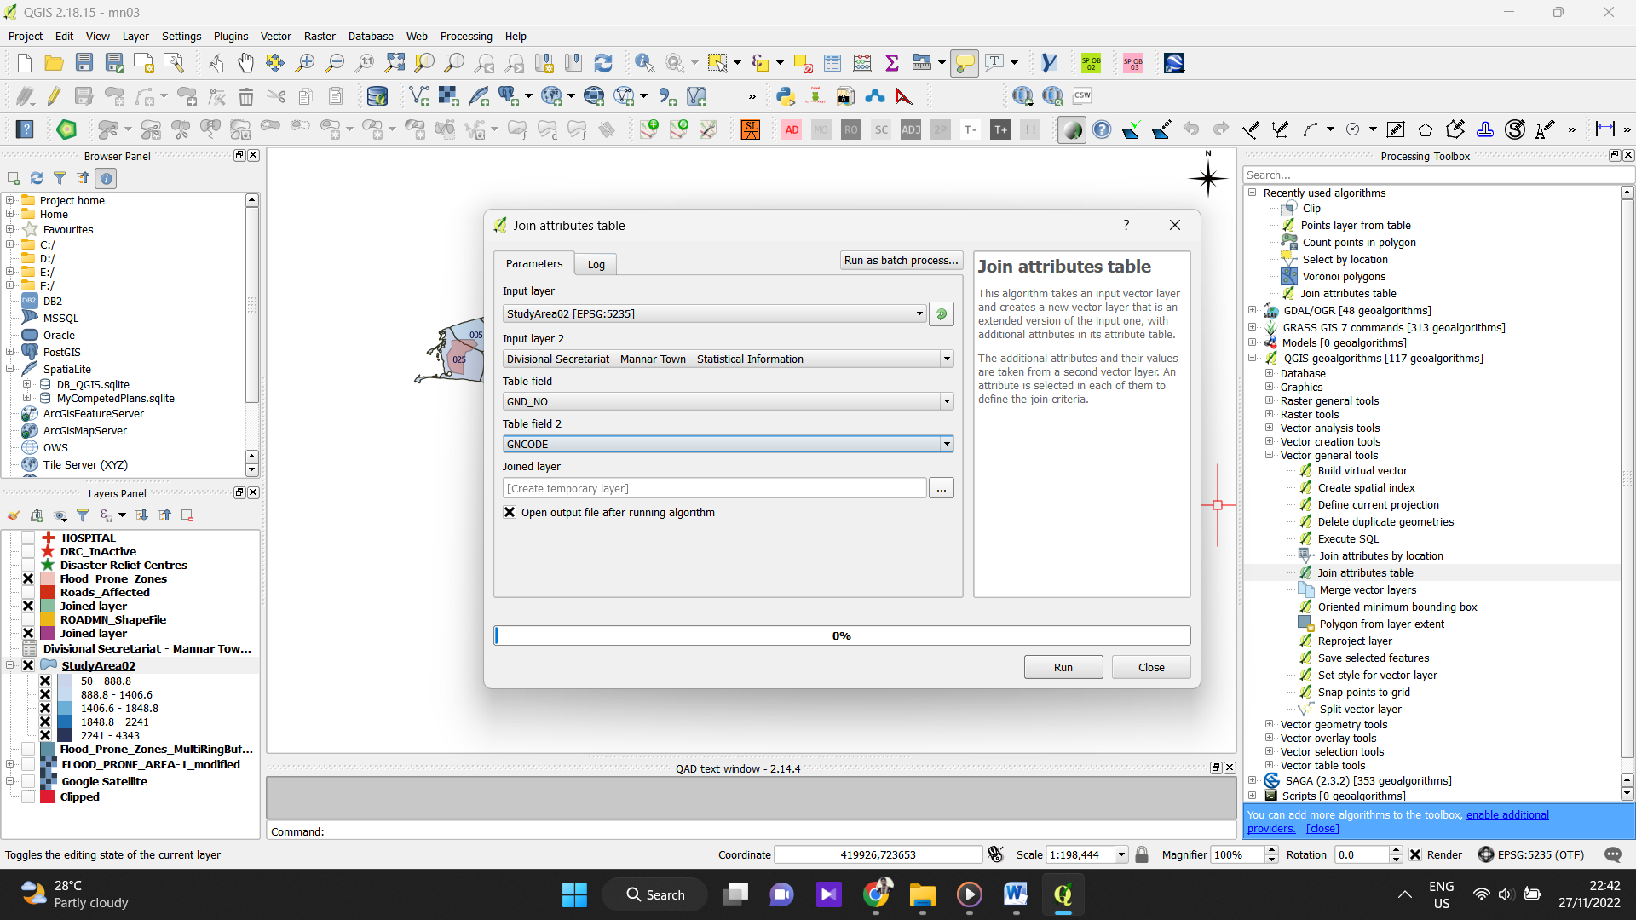

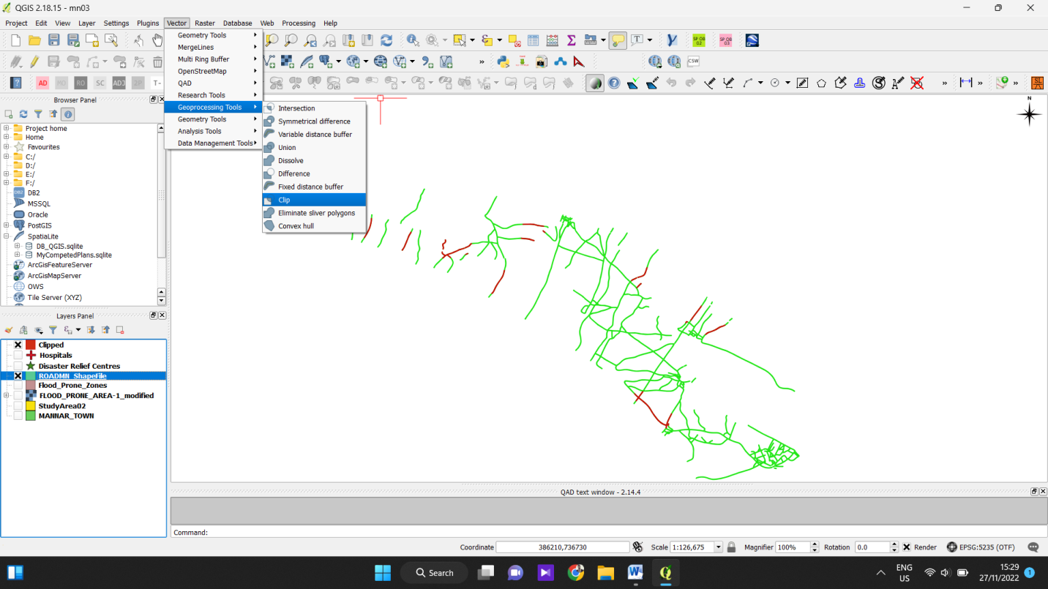
Finding Roads affected by Flood Area (Clip Tool)
And save.

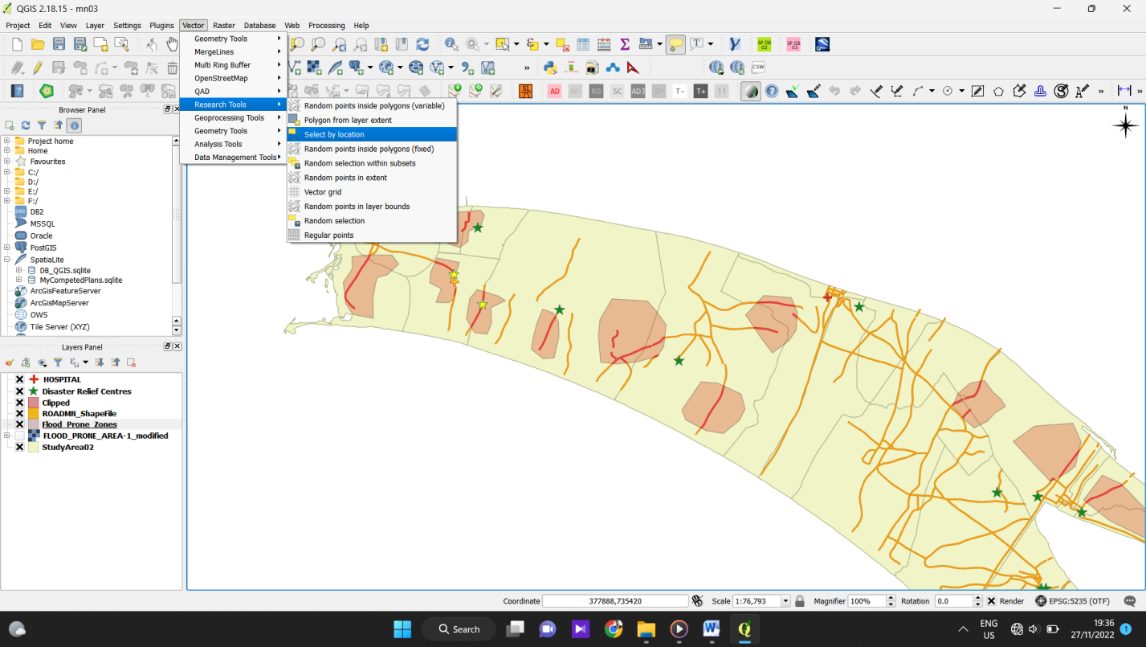
Finding the Disaster relief centers & Hospitals Inside the Disaster Prone Area.

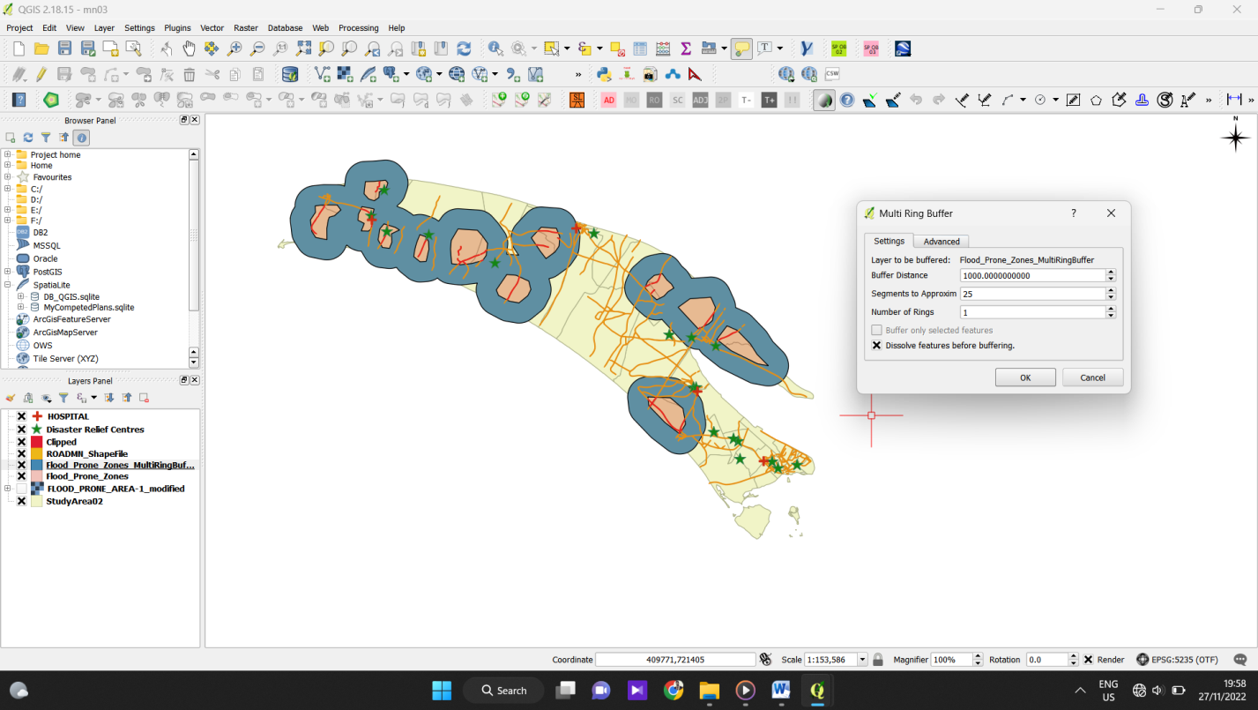
Finding the Nearby Hospital & Relief centers from the Prone area.
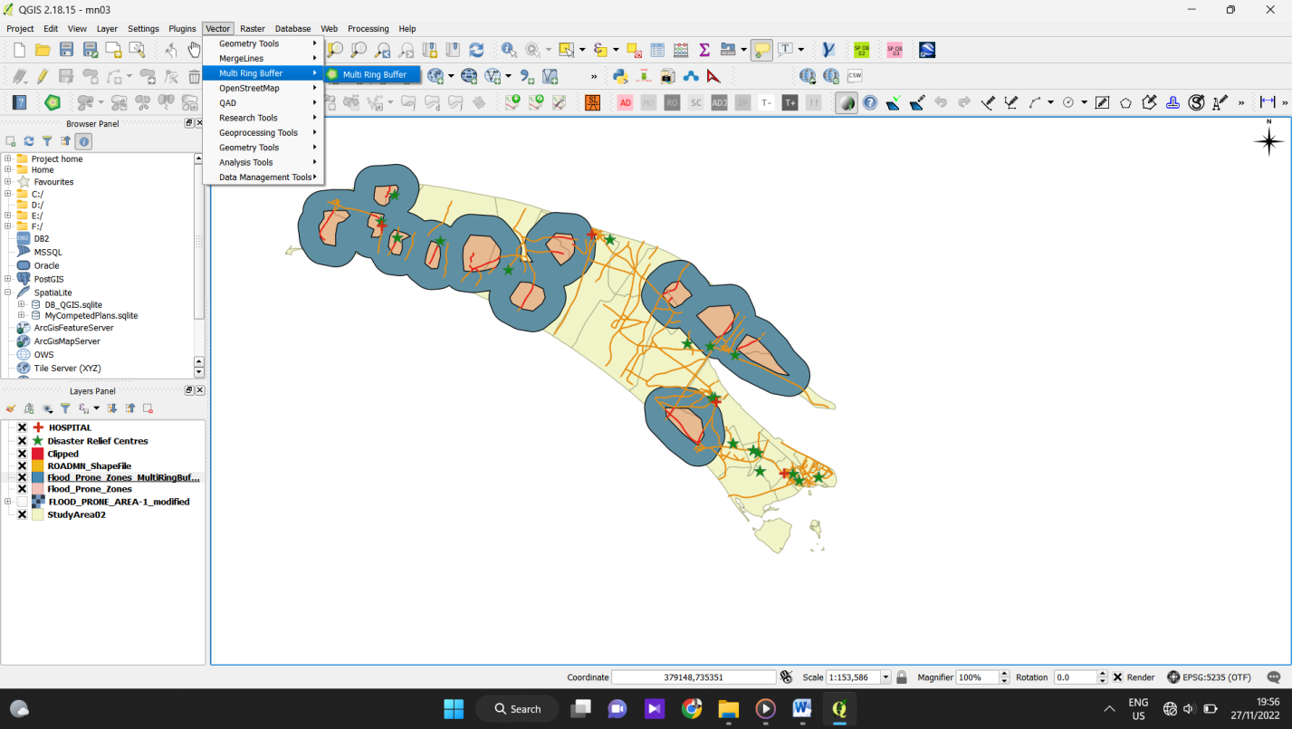
(With in 1km)
& Save as DRC_in Active.
Export to KML

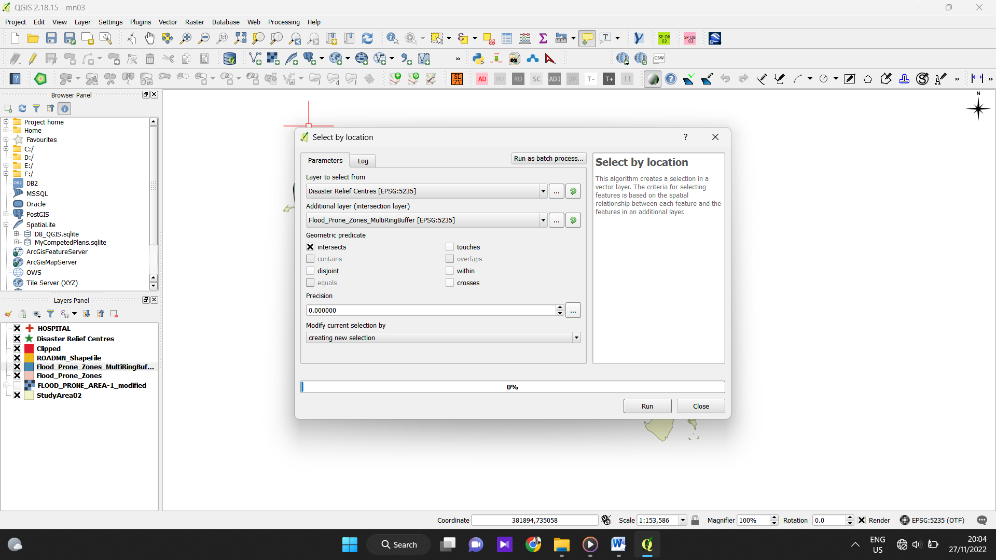

Preparing Final Maps.

